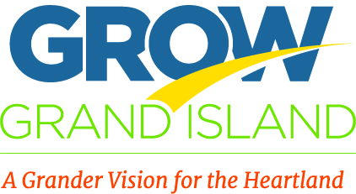
Initiative: 1.5 Regional Clusters

Objective: Work with neighboring communities in Central Nebraska to evaluate the potential benefits of developing regional cluster councils to address sector-specific issues and challenges that are common.

Chair: Tonja Brown
Committee: Mary Berlie, Harold Rosenkotter, Brad Bell, Karen Rathke, Bill Hunter, Sharon Hueftle, Tanya Potthoff, Cindy Johnson.

Next meeting: 4/20/16, 8am at the Chamber
Goal: | Timeframe: | Assignment: | Progress:
Identify potential clusters & explore. | Continually |  | Discussed were: manufacturing, medical/nursing, agronomy, banking, appraisers, skilled trades, 4-yr campus, night life culture.
Explore “manufacturing.” | 2015 | Complete | Determined HAMA & CPI had it covered.
Explore “stay home/come home.” | Q1 | Mary: present to YP & ask for their participation in a survey to identify issues/obstacles.  Tonja: share Nebr Rural Sourcing link; draft a survey.  Mary: look for other initiatives & research. | (1/12) Potential cluster members & issues were discussed. “Area” could include Doniphan, Aurora, CCity & SPaul.  (2/11) On the YP agenda.  (2/23) Mary reported YP has interest—we are to come back when the draft survey is ready. As a group, we discussed questions to include. We also discussed the Nebraska Rural Sourcing initiative (via UNK). Although the outcome was less than hoped for, there is some continuation of effort we may want to look closer at by inviting Shawn Kaskie to a future meeting.  (3/15) Tonja shared the survey draft and changes were discussed. An updated draft (link) will be emailed for further feedback. The final draft will go to YP on 4/14 for their distribution approval.

Meetings/Attendance:
1/12/16 Tonja Brown, Tanya Potthoff, Mary Berlie, Karen Rathke, Harold Rosenkotter (5x1hr=5hrs)
2/2/16 Postponed due to weather.
2/23/16 Tonja Brown, Mary Berlie, Bill Hunter (3x1hr=3hrs)
3/15/16 Tonja Brown, Bill Hunter, Tanya Potthoff (3x.5hr=1.5hrs)

