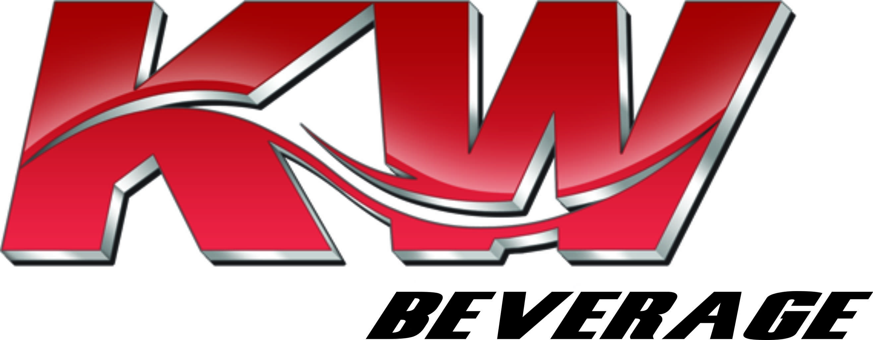

IF YOU HAVE A CLASS “A” CDL AND YOU’RE LOOKING FOR A POSITION

WITH AN ESTABLISHED, LOCAL COMPANY WHERE YOU CAN BE

HOME EVERY NIGHT & OFF EVERY WEEKEND,

THEN KW BEVERAGE IS WHERE YOU WANT TO BE.

- THE STARTING PAY FOR DELIVERY DRIVERS IS $46,800PER YEAR, PAID AT A RATE OF $180/DAY.

- AFTER 90 DAYS, PROVIDED THE DELIVERY DRIVER IS MEETING ALL REQUIREMENTS AND THEIR PERFORMANCE IS SATISFACTORY, THEIR PAY WILL GO TO $49,400/YEAR, PAID AT A RATE OF $190/DAY.

- THE DELIVERY DRIVER PAY WILL GO TO $52,000/YEAR, PAID AT A RATE OF $200/DAY, AFTER ONE FULL YEAR FROM THE DATE OF ORIGINAL EMPLOYMENT, PROVIDED THE DELIVERY DRIVER IS MEETING ALL REQUIREMENTS, THEIR PERFORMANCE IS SATISFACTORY, AND THEY ARE CAPABLE OF RUNNING ALL ROUTES.

- APPLY ONLINE @ KWBEVERAGE.COM – GO TO THE CAREER TAB & COMPLETE THE APPLICATION

IN ADDITION, WE ALSO HAVE A DRIVER “BOUNTY” PROGRAM

HERE’S HOW IT WORKS: THE INITIAL PAYMENT AFTER A “SPONSORED” DELIVERY DRIVER IS HIRED IS $250, AND AFTER SIX MONTHS, AN ADDITIONAL $250. IF THE “SPONSORED” DELIVERY DRIVER CONTINUES THEIR EMPLOYMENT FOR A YEAR, THE “SPONSOR” WILL RECEIVE A $500 BOUNTY.

ALL BOUNTY PAYMENTS ARE CONTINGENT UPON THE “SPONSORED” DELIVERY DRIVER MEETING ALL REQUIREMENTS AND MAINTAINING SATISFACTORY PERFORMANCE STANDARDS. ONLY EMPLOYEES OF KW BEVERAGE ARE ELIGIBLE TO RECEIVE A BOUNTY PAYMENT.

OUR BENEFITS INCLUDE:

- GROUP MEDICAL, DENTAL, VISION AND PRESCRIPTION DRUG PROGRAM, WHICH ALSO INCLUDES LIFE INSURANCE, SHORT TERM DISABILITY AND LONG TERM DISABILITY.

- 401(K) WITH A 6% COMPANY MATCH

- ROBUST PAID TIME OFF (PTO) PROGRAM WITH TIME OFF ACCRUED IN FIRST YEAR WITH THE COMPANY.

CONTACT JESSE BAZEMORE 803-600-6960 OR EMAIL JESSE.BAZEMORE@KWBEVERAGE.COM
WEBSITE: KWBEVERAGE.COM

