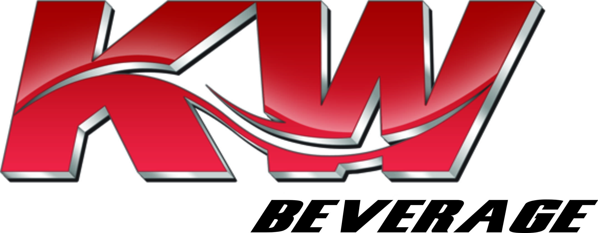

FORKLIFT OPERATOR
Second Shift
JOB DESCRIPTION

BASIC PURPOSE:
To follow the specific guidelines developed by KW Beverage concerning the warehouse process for safe and effective material movement of all KW Beverage’s products. Reports directly to the Second Shift Warehouse Shift Supervisor under direction from the Warehouse Manager.

PRIMARY RESPONSIBILITIES:
- The Forklift Operator is responsible for operating a forklift to move, locate, relocate, stack, and count merchandise.
- The Operator is accountable for the safe and efficient operation of the vehicle.
- Efficiently stack and store the merchandise in the appropriate areas.
- Quality: Ensure inbound and outbound shipments are accurate and free of damage.
- Report quality variances.
- Order Picking: Pull and prepare product for shipment, ensuring that the exact number and type of product is loaded and shipped. Perform picking duties in an efficient manner that meets customer service standards.
- Loading: Efficiently move product from staging and/or storage areas into trailers.
- Equipment: Load, unload, move, stack, and stage product and materials using a forklift or other power equipment.
- Use radio frequency equipment for picking, receiving, put-away, and load functions, as required.
- Maintain the facility’s equipment and materials in a neat, clean, and orderly fashion.
- On a daily basis, perform pre and post shift inspections on the forklift or other equipment.
- Inventory: Keep appropriate records and reports to guarantee that tight inventory control and security are maintained. Assist in physical inventories. Ensure proper stock rotation.
- Safety, Sanitation, Security: Maintain a clean, neat, and orderly work area. Assist in maintaining the security of the warehouse. Conduct operations in a manner that promotes safety. Comply with OSHA and MSDS Standards.
- Maintenance: Perform or assist in building, grounds, and equipment maintenance as required. Accountable for product damage and package integrity.
- Must keep work area clean and neat throughout the shift.

EXPECTATIONS:
- Must be able to work second shift Sunday thru Thursday, 4:30 pm until or at a set time as your job requires
- Always maintain a neatly groomed personal appearance and a fresh, wrinkle free uniform every day.
- All facial hair (beards, goatees and mustaches) must create an overall neat, polished and professional look.
- Must be to work on time, attend all meetings and training sessions daily.
- Must tolerate some long hours depending on the season, etc.
- Work as part of a team and help your teammates when necessary.
- Must attend all safety classes before using lifts and handling products.
- Operate all equipment in a safe and efficient manner following prescribed work methods.
- Learn the Anheuser-Busch and other supplier beverage freshness code system and apply it to working the pick line.
- Must be able to read all product code dates.
- Must be willing to train new warehouse reps when asked.
- Must be safety conscious and strive to be accident free in all aspects of the position.
- Work to minimize damaging product while stacking packages on pallets.
- Making decisions as an individual for the betterment of the team is a must.
- Organized and detail orientated.
- Must be knowledgeable and comply with all company policies.
- Must perform any other duties requested by management.

The following physical demands are required but not limited to:

Walking, Sitting, Lifting 20 to 165 lbs., Carrying, Pushing, Climbing, Stooping, Bending, Kneeling, Reaching, Pulling, Standing

