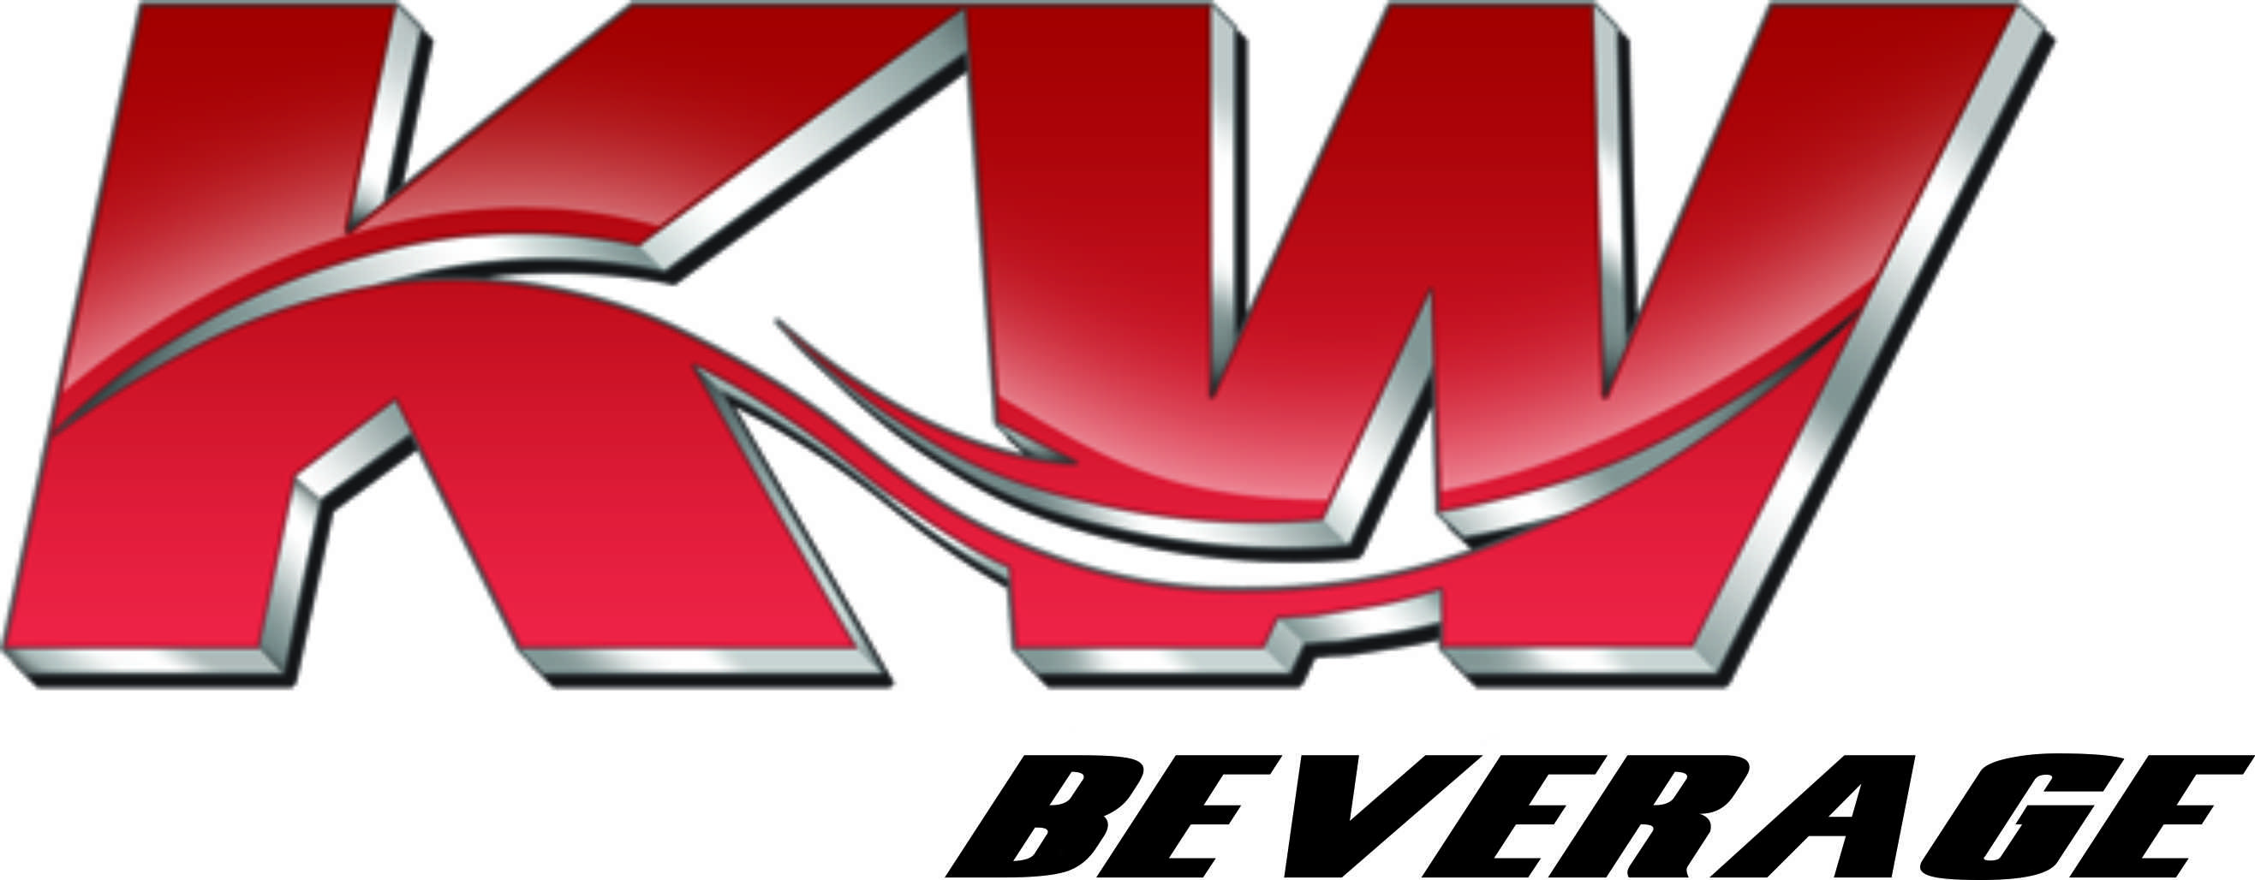

SALES SUPPORT

KW BEVERAGE/COLUMBIA BRANCH

JOB DESCRIPTION

The sales support employee is responsible to the Team Leader. The duties include:
To aggressively sell and distribute all brands and packages as well as those of other partners carried by KW Beverage. and to follow the specific guidelines developed by KW Beverage concerning the selling, rotation and delivery of all suppliers’ products.

- Receive daily assignments of work to be completed from the Team Leader.
- Fill in, manage, service and aggressively sell to customers according to route specifications set up by the sales manager and chain manager.

- Have the ability to work as a unit with designated team leaders and delivery drivers to achieve personal and company goals.

- Maintain a professional rapport with all customers.

- Maintain a structured sales call on all assigned accounts.

- Minimize product out-of-stocks in all accounts.

- Maximize display execution in all accounts.

- Stock, merchandise, and reface product in displays, coolers, ice barrels, hot shelf, etc.
- Maintain and grow shelf space for all brands and packages and initiate resets when necessary.

- Responsible for tracking dates in mobility and for 100% of out-of-date beer product in accounts.

- Maintain weekly display tracking through “Go Spot Check” for fill in route.
- Understand and adhere to KW Beverage code date policies and all brewer partners.
- Responsible for borrowing and returning tools, items and necessary supplies for hanging/maintaining Point of Sale (P.O.S.)

- Merchandise accounts and displays with up-to-date P.O.S. on a daily basis.
- Immediately document all competitive activity and send to Team Leader via email.
- Attend all company sales meetings unless excused for vacation, illness, or personal reasons by appropriate supervisory personnel.

- Wear proper KW Beverage attire and be neat and clean in appearance daily.
- While borrowing vans, adhere to all state laws and maintain a clean vehicle. Keep adequate P.O.S. to maintain sales area.

- Report all accidents immediately to the fleet manager/team leader/human resources and safety manager.

- Responsible for checking with Team Leader regarding the acceptance of checks or the collection of returned checks per company’s check policies.

- Assist in the development and execution, as well as measuring and tracking sales programs.

- Orders will be made Monday thru Friday.

- Start time is 7:00 A.M. Monday thru Friday, or as directed by management.
- Maintain hardware and items on lend from KW Beverage such as iPad, cell phone etc.

- Submit orders after each account and before the designated time i.e., Grocery 3:00 PM and C-Store 5:00PM every day.

- Provide a full recap for the account manager upon returning to assigned route.

- Follow all company policies and procedures.

- Perform any other duties as assigned

ESSENTIAL FUNCTION:
The ability to read, understand merchandise pricing and demonstrate basic math skills related to the same are also required of this position.

The following physical demands are required but not limited to:
Walking, Sitting, Lifting, Carrying, Pushing, Climbing, Stooping, Bending, Kneeling, Reaching, Pulling, And Standing.

