The temple of Abu simbel

a monument and a symbol
(A lecture in the Architectural Association, London, 18.1.01)

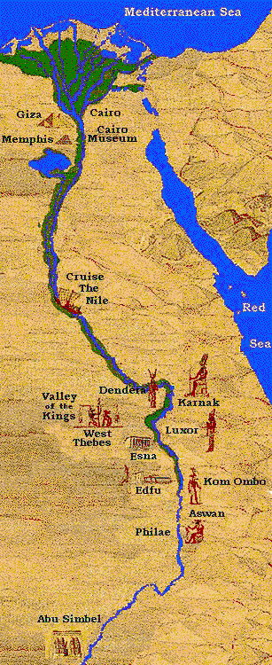 | 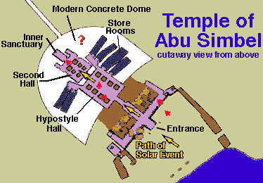
Today we are going to speak about one of the most impressive buildings in the ancient world – the temple of Abu Simbel. We are going to give an interpretation to the monument, using psychological tools from a symbolic point of view.
These two temples are located near the southern border of ancient Egypt, 300 kilometers south of Aswan approximately 1000 kilometers from Cairo.
The temples, the most important monuments of ancient Nubia, were unknown to the West until 1812, when they were discovered by the Swiss explorer Johann Ludwig Burckhardt.
Both of them were exposed. There is a beautiful painting of the biggest of the two, painted by David Roberts at 1838.

The temples were carved into a sandstone cliff in about 1250 BC during the reign of Ramses II.
Ramses II was one of the greatest kings of ancient Egypt. He was a great builder – many of the biggest buldings in Carnak were constructed by him. He built more temples, took more wives (8), sired more children (over 100) than any other pharaoh. He was buried in the valley of the kings in Carnak.

The smaller temple was dedicated by Ramses to his queen, Nefertari, and to the goddess Hathor.

The larger temple was dedicated by Ramses II to the gods of Heliopolis, Memphis and Thebes.
The interior of the temple is more than 55 m (180 ft) in depth and consists of a series of rooms and chambers leading to a central sanctuary.
The facade of the larger temple has four sitting statues of Ramses II, each more than 25 m (65 ft) heigh. The noses of the statues are almost 1 metere long. The king faces eastwards, towards the rising sun.

If you want to see the man behind the deeds – here he is:

The mummy was found in 1881 in Deir el-Bahri

The temple has numerous inscriptions and reliefs, some of them of unusual historical interest.
In 1964 an international project was begun to save the temples from inundation by Lake Nasser, the reservoir of the Aswan High Dam. In a remarkable engineering feat, the temples were cut apart and, in 1968, reassembled on a site 64 m (210 ft) above the river.
The Monumental statues, the huge halls, the thousands of carved figures; raises many questions: why did they built the temples? What was the motivation of the builders – the king, and the workers - thousands of whom died from the difficult work and the terrible weather.
Can we assume that only a caprice of a crazy king stands behind this work?
We now know that the huge building of antient Egypt were built by citizens and not by slaves. So it is not reasonable that the workers had no interest in the work.We shall ask how did Ramses give his people the feeling that they were taking part in something which is bigger then life, which is more important then life itself.
Let us take a short journey in the temple:
* Re-Horakhte
In the center of the façade, above the door, we can see a relief of Re-Horakhte – one of the sun gods. The god is represented with the attributes of both Re (the sun disk) and Horus (falcon-head).
On each side ther is a relief of Ramses II offering a sacrifice to Re-Horakhte.
Now, this figures in the center of the façade symbolize the leitmotife of the temple: the connection to the great energies of nature, of the sun.
The temple was built near the gold mines. The gold, the pure metal which comes from the inner ground is a simbol of power. For the encients the metals inside the earth, and espacially the gold, symbolized the power of earth, the energies of nature.
In order to shed light on the many questions we raised about the spacial design of the temple and it’s contents, we shall add a theory taken from depth psychology: the archetypal theory of Karl Gustav Jung. But befor that let us take a little journey inside the temple.
In the coridor we find Nile gods (Happi) of lower and upper Egypt binding the flowers : the lily and the Papyrus, symbolic of the two parts of the country
Above is the cartouche of Ramses II
When I was there, the guide wanted me to say something about the relief because archeologists believe that psychology has to do with pathology, and these figures are androgynous.
Instead I asked him whether in Ramses’ time the question of uniting the two parts of Egypt was really an important issue. He replied that for hundreds of years this was not an acute problem. The fact that the scene was not taken from reality was the drive for me to interpret Egyptian art with symbolic tools. The king crowned with the double crown of Egypt – lawer and upper Egept, symbolizes unification,and it has nothing to do with the political situation.
Let us continue our journey.

Inside the temple ther are three halles separated by two doors which you can see in the picture.

The ceiling of the first hall is supported by massive pillars. Each pillar is a statue of King Ramsses dressed as Osiris God.
Osiris, according to the widespread legend, was killed by his brother Set who cut him to pieces. He was then reunited and resurrected by his sister Nefftis. So Osiris is the god of eternity. Osirification means becoming eternal, and beside that he is the symbole of the great contradictions life and death.

On the wall of the first hall we see some historical events. Thousands of people are in the description of The Battle of Kadesh, a battle led by Ramses against the Hitteits near the Orontes river.

In the second hall we see the kings family: his wife and his many children.
Let us go through the second hall to the third hall.

Here we see the major Egyptian Gods and Ra-amses between them.
Before going into my interpretation of the temple I want to emphasize that ther are three halls in the temple, but only two of them are described in books.
I find the fact that they neglected the second room to be quite strange. Maybe it is due to the fact that the descriptions were not based on a theory. Therfor they couldn’t find any special meaning in the contents of the second room.

Now let us take another look at all the questions we raised according to a theory I heard from an old teacher,The jungian psychologist Jack mendelson, to whome I would like to dedicate this lecture.

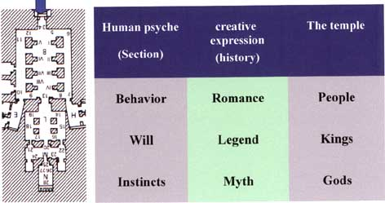

Mendelson explained that we can draw parallel between the stages of development of human creative expression and the structure of human psyche.
The first human literary creation was the Myth. Every nation has its ancient Myth, which describes the world of the Gods, the great powers of creation. Neitchze was the first to understand the psychological meaning of the Myth. He said: In it’s childhood, every nation creates its Myth and poetry and in it's menopause it creates philosophy and science…
Karl Gustave Jung was a student of Freud. Unlike Freud, he didn’t look at the unconcious as just a personal container for unacceptible contents. He believed in the existance of a collective unconciuos. This level of the psyche is the reservoir from which emerges creation and intuitive knowledge. After working some years with Freud, Jung focused his view on the wide parallels between dreams and the ancient myths, and these parallels became the corner-stones of his theory.
The stage of the myth is the stage of the great powers – The Gods. In the psyche it represents the level of the instinctive powers. But not only the physical instincts are there. Here we find the archetypes. Those are the ancient patterns of human behavior. These are the resources of the psyche.
The second stage after the Myth is the stage of the legends, the fairytales. Here the heroes are already human beings, but there are still many subnatural figures like fairies and witches. Different researchers agree that fairytales are the legal daughters of the Myths.
Now, according to his psychological theory, Mendelson said that the stage of fairytale is the stage of the ego, becouse the will of the human hero is the key element in the legend, as well as in the ego. The upper stage which is also more modern, is the novel, the romance, where all the figures are taken from real life. This is the level of human behavior.

As we see, the three stages of human creative expression represent three levels of the psyche: The myth represents the innermost level, the level of the instinctive powers, the primal drives. The second level is the level of the ego, the emerging consciousness which is represented by the human hero.
The upper stage is the stage of external life itself, the events and behavior in exposed world.
Now let us look at the right side of the diagram:
In the first stage the central figures are the Gods – the non-human and non-personal figures. The central figures of the second stage are the human heroes. The hero goes through a voyage, in which he has to struggle against the outside obstacles and the inner powers. This is the hero’s journey towards awareness, recognition and control. He then becomes the king, representing the roles and functions of the ego, such as consciousness, control, and guidance. So we can say that the king represants the ego while the hero and his journey is a personification of the development of the ego towards maturation and independence.
In the first two stages we can see the unconscious powers: in the mythical stage they are at the front of the stage while in the fairytale they are pushed behind the scenes. In the upper stage, in the romance, we see only human beings, but the god Eros send his sharp arrows from unknown places.

Now let us go back to the temple:
Many of the symbols which accompanys Ramses have to do with unification and integration (the Nile gods above) . These are two of the main courses in the human psyche. It is very difficult to understand the urge towards integration. The natural tendency in the physical world is towrds fragmentation and crumbling, what we call “entropy”. The integrative tendency is the peculiar answer to the easily understood tendencies towards fragmentation and crumbling. The integration impulse is one of the great riddles of psychology.
Here we can see the meeting between ecology and psychology: contradictions and conflicts are the main elements of the human psyche. Contradictions like good and evil, spirit and matter, male and female, are the elemants which builts the psyche. The tension between the inner poles is the source of both suffering and creativity.
In the natural world, contradictions exists everywher. Especially in Egypt we see opposits everywher: The dry desert and the cultivated land, the cold nights and the hot days, the silent flow of the Nile and the stormy flood. All these opposites, both psychological and ecological, were condensed in the great pair of symboles: Upper and lower Egypt, and Happi, the god of life and death.
And the king was asked to bring the answer to all these riddles of uniting and building bridges between the contradictions, between the opposites which can bring crumbling or death, on one hand, or life and productivity on the other hand.
I must emphasize that in ancient cultures they didn’t distinguish between the questions of the outer world and the inner world. The world was one and the same everywhere. There were levels of reality, but everything was real, and the king was required to give the answers to all the questions of heaven and earth, of life and death, of separation and unification.
Let us look at the two doors (above):
Two doors, three halls.

In the first hall we see hundreds of people fighting. The drawings describe the battle between the Egyptians and the Hittites in Kadesh, near the Orontes river. In the scene described, the Egyptians had captured two Hittites prisoners who told under investigation that there were no soldiers on the other side of the river. When the Egyptians crossed the Orontes they realized the Hittites had ambushed them. The Hittites had almost defeated the Egyptians but the latter were saved by King Ramses. This hall clearly describes human figures and human action.

Second hall:
As I said before, in most of the books the second hall is not mentioned at all. In the second hall we find the second stage: the King, his wife Nafarteri, and his children (he had hundred children, and lived 80 years). These are the symboles of the legend.
The Sanctuary:
In the innermost place we see the gods. The great powers, the sources of the world, the sources of the psyche. From left to right sitting Amon ra, Ptah, Raamsses and ra Churakhte. Raamses is a deity and a humanbeing at the same time. He represents the connection of human beings to the great powers. This is why we see his figure everywhere in the temple, on the façade, in the halls, in the sanctuary. His integrative function connects heaven and earth, light and night, good and evil.
This was the source of the motivation to build this temple. Is it enougth for explaining the efforts needed for such a project? I think the answer is: yes.
I did a study of the great dictators in the history. And I found that most of them used these symboles I found in abu symbel temple: they tried to transmit a feeling of connection to the ancient resources of the nation, and if ther were not such – they invented them (like Atha Turk who built a museum for the Hittite cultere). They spoke about uniting the nation. Even now if somebody wants to become a primeminister he says he is goin to be the president of everybody.

And the people who worked for that felt that they were taking part in somethig which is greater than life. They felt that they touch the eternal.
For this it is worthwhile to live, and to die, and to carve a temple.

The temple’s orientation was arranged in such a way that every year, on February 21, a ray of sun goes through the three doors, shines on the forehead of Amon ra, moves to the breast of Ramses and vanishes. It symbolizes the flow of energy from its natural sources to life on earth, from the instinctive level of the psyche, nourishing the ego powers. February 21is the birthday of Ramses II.
As I said befor, the temples were moved from their place by an international expedition supported by UNESCO in 1964. The young Nubian guide told us that the engineers which were responsible for the directions were americans. Now, after the displacement of the temple this event of the penetrating sun’s rays takes place on February 22nd, George Washington’s birthday.
I was told that now the sun rays falls somewhat lower to the breast, on the instinctive level of Ramses…

As you can see, the design of the temple is alike human body.
So, we see that ther is a wide parallel between the temple of Abu Symbel and the structure of human psyche, and the parallels includes the design, the carved figures, the statues – the architecture and the art, and it conects the temple and its builders to the integrative function simbolized by the temple and by the great king Ramses.

May be the shifting of the temple, by cutting it to pieces and reuniting them, more then any other thing symbolizes the main function of the temple…

